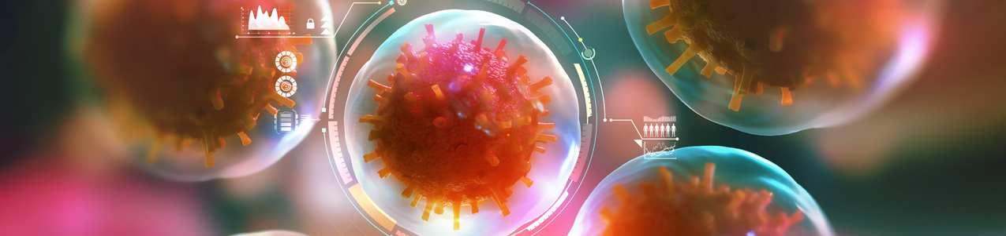

Please complete these questions and submit this form as an attachment to the IDR submitted for the Microbiome Challenge.

Provide a one-two page summary outlining:
- Market need your idea is addressing/problem to be addressed
- Your proposed research plan
- Work planned and timeline
- Budget
- Plan for future development
- Timeline
- Plans for potential future funding

